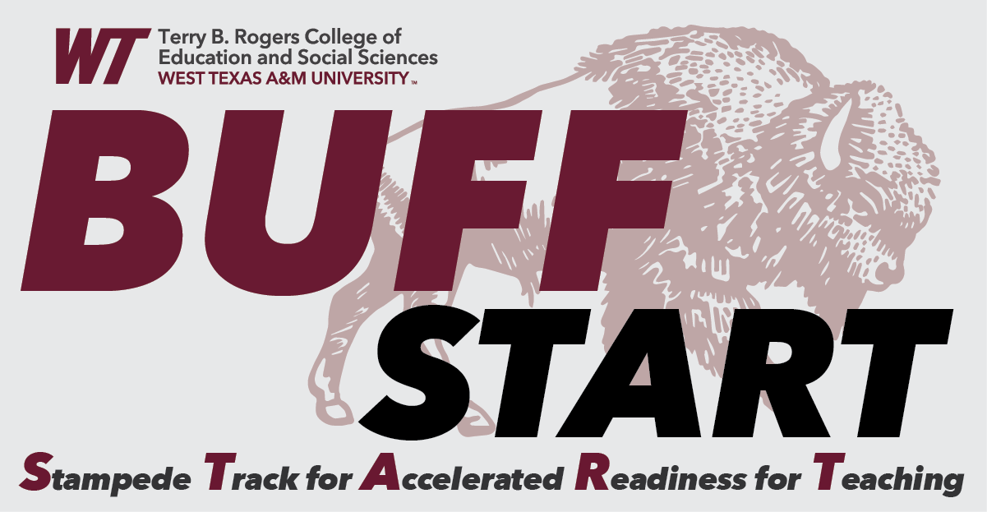
Degree Checklist

NAME ID# DATE DEGREE BS MAJOR Education CERTIFICATION CORE EC-6 TRACK ESL Track TExES TESTS 160, 391 & 293

NOTE: Please reach out to our Advisors for more information and to help coordinator past hours and transcripts.

Lead Advisor: Robin Johnson Advisor: Ray Rigoni

(806) 651-2610 (806) 651-2642
A. GENERAL EDUCATION (42 hours) | HRS | GRADE | C. TEACHING FIELD (57 hours) | HRS | GRADE
ENGL 1301 or 1311 (10) | 3 |  | (Must make a “C” or better and a 2.75 combined with section E)
COMM 1315 or 1318 or 1321 (10) | 3 |  | EDEC 2383 Early Child Education | 3
MATH 1314,1316,1324,1325,1332,1342,1350, 2412, or 2413 (20) | 3 |  | EDEC 3384 Curriculum & the Young Child | 3
ANSC 1319; BIOL 1406 or 1308, 1407* or 1309*, 1411, 1413; CHEM 1305* or 1411*,  1412*; ENVR 1407*; GEOL 1301 or 1403, 1302, 1404; PHYS 1401*, 1402*, 1311, 1312,  1371, 2425*, 2426*; PSES 1301, 1307  - BIOL 1406, 1407, 1411, 1413; CHEM 1411, 1412; GEOL 1403, 1404; PHYS 1401, 1402,  2425, 2426: 4th hr. moves to Core 90 (30) | 3 |  | EDRD 3302 Reading Skills I | 3
 | 3 |  | EDRD 4302 Reading Skills II | 3
ANTH 2351, ENGL 2321, 2326, 2331, 2341, 2343; HIST 2311, 2323, 2372; MCOM  1307, PHIL 1301, 2374; SPAN 2311, 2312, 2313, 2315, 2371 (40) | 3 |  | EDRD 3304 Structured Literacy I | 3
ARTS 1301, 1303,1304; DANC 2303, MUSI 1306, 1307, 1310; or  THRE 1310 (50) | 3 |  | EDRD 4305 Structured Literacy II | 3
HIST 1301, 1302, 2301, 2381, 2382 (60) | 3 |  | EDEL 4372 Teaching Writing | 3
HIST 1301, 1302, 2301, 2381, 2382 (60) | 3 |  | EDEL 3374 Social Sciences for Teachers | 3
POSC 2305 (70) | 3 |  | EDEL 4381 STEM Teaching & Learning | 3
POSC 2306 (70) | 3 |  | EPSY 3350 Children with Special Needs | 3
AGBE 2317, COMM 2377, CRIJ 1301, ECON 2301, 2302; GEOG 1302,  PSYC 2301, SOCI 1301 (80) | 3 |  | HUMA 3315 Fine Arts Fundamentals | 3
AGRI 2300; BIOL 4th hour from 4-hour courses (from Core 30); BUSI 1301, 1304; CHEM 4th  hour from 4-hour courses (from Core 30); CIDM 1105, CIDM 1301 or 1315; CS 1301;  ECON 2331; ENGL 1101, 1102, 1302*, 1312*, 2311*; ENVR 4th hour (from Core 30); GEOL  4th hour from 4-hour courses (from Core 30); IDS 1071 (1-3 hours); MATH 4th hour from 4- hour courses (from Core 20); MUSI 1053; PHIL 2303; PHYS 4th hour from 4-hour courses  (from Core 30); SES 1120 (90) | 3 |  | MATH 1350 Mathematics for Teachers I | 3
 | 3 |  | MATH 1351 Mathematics for Teachers II | 3
 |  |  | MATH 3301 Mathematics for Teachers III | 3
B. PROFESSIONAL DEVELOPMENT (21 hours) |  |  | NSCI 2371 Integrated Science: Earth Science | 3
(Must make a “C” or better and a 2.75 gpa combined with section C) |  |  | NSCI 2372 Integrated Science: Biology | 3
EPSY 3341 Educational Psychology | 3 |  | MCOM 2310 Media Design or  MCOM 3309 Multimedia Journalism | 3
EPSY 4341 Educator Readiness & Performance | 3 |  | EDPD 4378 Language Development (ESL Track) | 3
EDPD 4340 Classroom Management | 3 |  | EDPD 4388 ESL Teaching Methods (ESL Track) | 3
EDPD 4348 Data-Informed Instruction & Assessment | 3
EDEL 4371 Educational Methodology | 3
EDEL 4341 Clinical Teaching – Elementary | 3
EDPD 4398 Clinical Teaching—All Cert. Areas | 3
 |  |  | DEGREE HOURS TOTAL: 120

rjohnson@wtamu.edu rrigoni@wtamu.edu

COURSES NOT COUNTED TOWARDS DEGREE:
The university reserves the right to change admission, curriculum and/or degree requirements, and certification requirements to comply with state and federal policy/laws/regulations. The student assumes full responsibility for meeting all university requirements and for keeping current with changes that may affect graduation and/or certification.
TExES TEST
PPR:
CONTENT:
 | Hrs (a) | Hrs (c) | Hrs (e) | Gr Pts | GPA
TRANSFER
WTAMU
TOTAL

Currently Enrolled
Hrs Needed
Hrs Completed
Total Hrs

Major: Education – Core Subjects (EC-6) Certification Major Code: 860 (Education B.S.) – ESL Track
May Intercession A |  |  | Summer Session 1A
EPSY 3350 Children with Special Needs -OR-  EDEL 4381 STEM Teaching and Learning  -AND-  EDEL 3374 Social Sciences for Teachers (EOD)  NSCI 2371 Integrated Science: Earth Science (EOD) if Needed | 3  3  3  3 |  | EDEC 2383 Early Childhood Education  EDRD 3302 Reading Skills I | 3  3
Total: | 6 |  | Total: | 6
Summer Session 2A |  |  | Fall Semester
EDEC 3384 Curriculum and the Young Child  EDRD 4302 Reading Skills II | 3  3 |  | EPSY 3341 Educational Psychology (EOD)  MATH 3301 Math for Teachers III  EDRD 3304 Structured Literacy I  EDEL 4372 Teaching Writing  EDEL 4341 Clinical Teaching – Elementary | 3  3  3  3  3
Total: | 6 |  | Total: | 15
Winter Intersession |  |  | Spring Semester
EDPD 4378 Language Development | 3 |  | EPSY 4341 Educator Readiness and Performance  EDPD 4340 Classroom Management (EOD)  EDRD 4305 Structured Literacy II  EDPD 4398 Clinical Teaching – All Certificate Areas  EDEL 4371 Educational Methodology | 3  3  3  3  3
Total: | 3 |  | Total: | 15
May Intersession B |  |  | Summer Intersession 1B
EPSY 3350 Children with Special Needs -OR-  EDEL 4381 STEM Teaching and Learning | 3  3 |  | EDPD 4348 Data-Informed Instruction and Assessment  EDPD 4388 ESL Teaching Methods | 3  3
Total: | 3 |  | Total: | 6
1 CORE: Core Subjects (EC-6) Certification majors are required to choose from specific courses for Core 20. For all other categories, they may select from any available options (see degree checklist). Apart from the major-specific core requirements, there is no set order in which core courses must be taken.
2 Requirements to take EPSY 3341: Apply to the Educator Preparation Program; application submitted to Office of Teacher Preparation (Old Main 415); 2.75 GPA in overall WT/transfer hours combined or last 60 hours taken; 2.75 GPA in content field(s)/teaching field(s).
Additional notes: The core curriculum must total exactly 42 hours; excess hours must be moved to the major as an elective or a major requirement and stay within the 120-hour requirement or approved total submitted to the Coordinating Board for degree requirements. Some majors specify particular courses to meet core curriculum requirements when options are available.
- At least 36 hours of advanced work (3000- or 4000-level courses) for which tuition is paid must be earned at WTAMU. A maximum of six semester hours in religion (RELI) and six semester hours in physical education (PHED) courses can count toward a baccalaureate degree.
DISCLAIMER: This curriculum guide should be used in conjunction with the corresponding degree checklist for general planning purposes only. The degree checklist (later a student’s official degree plan) should be referred to as the comprehensive list of all courses required for the degree. An official degree plan is required after completing 30 hours. Students should always seek the advice of their academic adviser before scheduling classe

